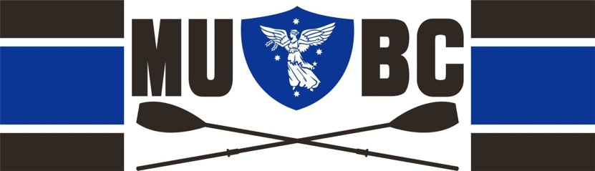

Visitor Participant Details

MUBC Supervisor ..................................................................................
Payment Required ................................................................................
Welcome to MUBC. Please complete the following in full:
Participation Date:.................................................................................
Name: ......................................................................... D.O.B................
Residential Address ...............................................................................
................................................................................................................
Contact Phone Number .........................................................................
Email Address .........................................................................................
Emergency Contact .................................................................................

I declare that I am fit for participation. I am over 18 years old

Signature ............................................................ Date ............................

Visitor Participant Disclaimer
Safety
When using MUBC equipment whether on water or off, visitor rowers assume full responsibility for their own safety and must provide an appropriate duty of care to other users.
Damage and Insurance
When using MUBC equipment whether on water or off, visitor participant assume full responsibility for its proper use. Any damage must be reported to your supervisor. In case of an insurance claim the visitor(s) that have used club equipment shall pay expenses up to the excess amount of $1000.
Waiver
In consideration of MUBC accepting my participation as a Visitor, I agree to this release of claims, waiver of liability and notification of risks. I agree and understand the terms and conditions listed above. I waive any and all claims against MUBC and agree not to hold it and/or any of its employees, coaches, members or other associated club representatives for any personal injury, death, property damage or loss sustained by me as a result of my rowing participation.
Name of Visitor............................................................Date......................... Signature of Visitor ......................................................................................

